Title of the communication (Times, 14, bold)
Firstname LASTNAME ª, Firstname LASTNAME ª, Firstname LASTNAME ª, Firstname LASTNAME * (Times, 12, presenting author underligned)
ª Address (Times, 12, italique)

*Corresponding author : xxx.xx@yyyy.fr (Times, 12)

Text in Times 12 pt, maximum one page A4, figures and references included. Text must be written in English. References must be incorporated in the text following this format [1].

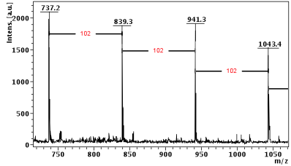
Figure 1 : xxxx
Références
[1] H. Brown, R. Waymouth Accounts of chemical research, 2013, Vol 46 (11), 2585-2596.
[2] J. A. Semlyen. “Cyclic Polymers”, Kluwer Academic, 2nd edn, 2000.
[3] M. Schappacher, A. Deffieux Science, 2008, Vol 319, 1512-1515.
[4] J. Hoskins, S. Grayson Polymer Chemistry, 2011, Vol 2, 289-299.

